Software Requirements Specification
for
AADHAR QR BASED VERIFICATION
Version 1.0 approved
Prepared by Royston Cardoz , Harsh Jain , Sayli Mhatre
<organization>
February 26, 2020
Table of Contents
Table of Contents ii
Revision History ii
1. Introduction 1
1.1 Purpose 1
1.2 Document Conventions 1
1.3 Intended Audience and Reading Suggestions 1
1.4 Project Scope 1
1.5 References 1
2. Overall Description 2
2.1 Product Perspective 2
2.2 Product Features 2
2.3 User Classes and Characteristics 2
2.4 Operating Environment 2
2.5 Design and Implementation Constraints 2
2.6 User Documentation 2
2.7 Assumptions and Dependencies 3
3. System Features 3
3.1 System Feature 1 3
3.2 System Feature 2 (and so on) 4
4. External Interface Requirements 4
4.1 User Interfaces 4
4.2 Hardware Interfaces 4
4.3 Software Interfaces 4
4.4 Communications Interfaces 4
5. Other Nonfunctional Requirements 5
5.1 Performance Requirements 5
5.2 Safety Requirements 5
5.3 Security Requirements 5
5.4 Software Quality Attributes 5
Appendix A: Glossary 5
Appendix B: Analysis Models…………………………………………………………………...6

Introduction

Purpose
You might have faced problem at different places for verification by police for Driving license, PUC, Insurance not only by police but by different government official or by different authorities. The Aadhaar QR card-based verification will eliminate all this problems or issues and say bye to carrying all these documents. Aadhaar QR card-based verification will bring the all these documents in it directly. It might take time in starting as Official department has to upload the documents in the application.

Document Conventions
Font Style Size
Heading Times New Roman Bold 18
Sub-Heading Times New Roman Bold 14
Other’s Arial Regular 12

Intended Audience and Reading Suggestions
- We are developing our project Aadhar QR based verification for the RTO based problems. But this project can be deployed in any other fields .
- This SRS is mainly developed for the project development team. In this team there are the project manager, developer, coder, tester and documentation writer and the user of the project also.
- User (Customer): This document is intended for users and customers to make them ensure that this document is well meeting the needs of the users.
- Project Manager: This SRS document is also very important for the project manager to ensure that he can estimate the cost easily by referring to the SRS document and that it contains all the information required for planning the project.
- Project Developer: The project developer will refer to the SRS document to make sure that they developed exactly how the customer requires.
- Tester: The tester will read this SRS document and he will ensure that the requirements are understandable from a functionality point of view so that he can test the software and validate its working.

Project Scope
Being an identification and verification system, the system has lot of scope for improvement. The system carries out work faster and efficiently. A lot of manual work in later stages is reduced to a large extent. The system needs to be maintained from time to time i.e. for adding new users as well as modifying details of users.
- The system can be expanded for more departments.
- Documents such as passports and voter ID can also be included in this system
- Some more advanced features will be added to improve work experience.
- User Interface will be made more user friendly and appealing.

References

[1] Wiss,”Computing in the s”, networker, vol. 11, no. 4, pp. 16 -25, December 2007.

[2] M. Baker, R.Buyya, and D. Laforenza, “Grids and grid technologies for wide area distributed computing”, International Journal of Software: Practise and Experience, vol. 32, pp. 1437-1466, 2002.

[3] B. R. Kandukuri, V, R. Pasture and A. Rakshit, “ Security Issues,” in proceedins of the 2009 IEEE International Conference on Services Computing, pp. 517- 520, September 2009.

[4] A. Weiss, “Computing in the s”, networker, vol. 11, no. 4, pp. 16-25, December.

[5] “Technology in the Security Management of Enterprise Document”, IEEE International Conference, by Na Liu, vol. 30, pp. 344-360, 2011.

Overall Description

Product Perspective
The Aadhar QR based verification is a digital platform that replaces the need to carry the hard copy of the important documents for the users. The system makes it feasible for the officers to check the documents on-location.
The context diagram illustrates the external entities, the interconnections of the system and system interfaces. The system is expected to evolve over several services provided , ultimately it connects the users and officers for easy access to the documents.

Product Features
- It increases data reliability.
- Reduce the hardware cost and the physical spaces.
- Easier group collaboration.
- Universal document access.

User Classes and Characteristics
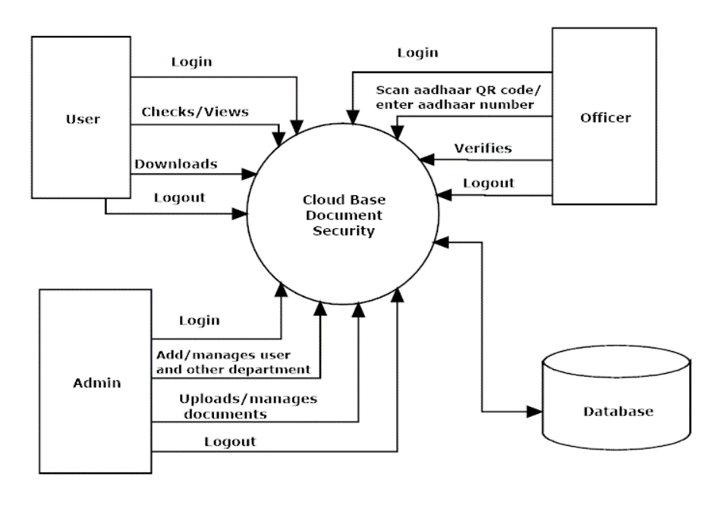

- Admin - An Aadhar QR based verification System has many users creating their accounts, making it difficult to handle the documents and records of every specific user who have looged in. hence admin keeps the records of all the users and the officers. All the account details of the users are even shared by the system to the admin. It keeps the report and uploads the documents of the users.

- Officer - The officer also creates an account. Through this account, they can scan the code or enter the number. The documents are verified and the officers then give the confirmation status to the system and the user.

- User- The user provides the system with the details. The system then provides the user with the list of documents. After getting the list of documents the user uploads the required documents. The system then acknowledges the users with the status of their uploaded documents. The documents can be downloaded offline.

Operating Environment
OE-1: The product will be operating in the Android studio environment.
OE-2: This System is an application and shall operate in all android devices with a camera to scan the QR code. Also it will be compatible with IE 6.0.
OE-3: Most of the features will be compatible with Mozilla Firefox and Opera 7.0 or higher. The only requirement to use this online product would be internet connection.

Design and Implementation Constraints

CO-1: The information of all the users must be stored in a database that is accessible by the RTO police officer.
CO-2: The information security system must be compatible with the Internet applications. The System is connected to the RTO police computer as well as mobile devices and is running all 24 hours a day.
CO-3: The users access the System from any computer or mobile devices that has Internet browsing capabilities and an Internet connection.
CO-4: The users must have their correct aadhar card number to enter into the System.

User Documentation
UD-1: The nature of these systems is unique to application development as they combine aspects of programming (hyperlinks, etc) with aspects of technical writing (organization, presentation).
UD-2: Online help is provided for each and every feature provided by the system. The user manual should be available as a hard copy and also as online help.
UD-3: An installation document will be provided that includes the installation instructions and configuration guidelines, which is important to a full solution offering. Also, a Read Me file is typically included as a standard component.
UD-4: The Read Me includes a “What’s New With This Release” section, and a discussion of compatibility issues with earlier releases.
UD-5: Most users also appreciate documentation defining any known bugs and workarounds in the Read Me file.
UD-6: Since the installation of the Online Library System is a complex process, our experts will do it. So an installation Guide will not be provided to the user.

Assumptions and Dependencies
AS-1: The users have sufficient knowledge of computers and mobile devices.
AS-2: The mobile device or computer should have Internet connection and Internet server capabilities.
DE-1: The users know the English language, as the user interface will be provided in English.
DE-2: The product can access its personal documents.

System Features

Login and verification:
3.1.1 Description and Priority
In this system, a user whose identity has been verified and whose documents are uploaded is given proper security. The documents can be available offline. The system is verified hence there is no risk in uploading the documents. The application is less vulnerable to attacks. Priority = Medium.
3.1.2 Stimulus/Response Sequences
- Stimulus: User logs in the application.
- Response: System grants access and user information is stored in the database.
- Stimulus: User QR scans his documents and uploads it on the application.
- Response: The documents will be verified and saved.
3.1.3 Functional Requirements
REQ-1:
- User should login and create an account.
- Fill in all the details.
- All the required documents should be uploaded.
- With the help of the app and scanning of QR code the documents will be available for the user online as well as offline.
- Use technology – for getting easy access to your own documents without carrying the hard copy.

Offline viewing and verification
- Offline availability of important documents.
- User documents will be verified.
- Constraints on design –
- Response time of the system is less than 3 seconds. Documents are mostly available offline.
- Throughput of the system is as per the need of the users.
- Resource usage of the system depends on the documents mentioned.
- The documents of the user will be available online as well as offline.
- Constraints on technology –
- Technology constraints of the system are .net framework, ASP.net, Microsoft SQL server, Android, Android Studio, QR code.
- Constraints on development plan – Development constraints of the system do not need any money.
- Constraints on project planning - System testing is done with various testing strategies like white box testing, black box testing, unit testing, etc.

External Interface Requirements

User Interfaces
UI-1: The design or layout of every form will be very clear and very interactive to the user.
UI-2: When the user opens the software the welcome window will appear.
UI-3: In the login window the user can easily enter the aadhar card details.
UI-4: Then it will give the successful login message.
UI-5: From each and every window the user can easily go to any desired window that is there will be an absolute and relative linking.
UI-6: In every window & Mac there is a help and support option that is present for the ease of the user.
UI-7: There will be a proper collection of GUI interface, which will provide a better look and feel.
UI-8: In the screen layout the background color is very light and the graphics and font style will be in proper manner and well organized.
UI-8: In each and every window there will be an alert, confirm etc message box for displaying Message.
UI-9: The user will be able to search any data from the record by using the proper guideline shown in the window & Mac.
UI-10: This will provide better security data because the menu window will be displaying according to the login (admin or normal user).
UI-11: Users can easily keep track of the records of insurance, puc and vehicle paper etc.
UI-12: This software will be easily understandable and operable by the user.

Hardware Interfaces
Since it will all be handled in a standard web browser. The only hardware interface will be for the scanning of QR codes to accept authentic documents. All that is necessary is a device that has a camera to scan the QR code on the screen of another mobile device. Any smartphone or tablet will most likely satisfy this requirement.

Software Interfaces
SI-1: A firewall will be used with the server to prevent unauthorized access to the system.
SI-2: Database used for viewing and verifying the document.

Communications Interfaces
CI-1: The Aadhar QR based verification system shall send an email messages to the user to confirm acceptance and verification of the documents.
CI-2: The Aadhar QR based verification system shall send an email messages to the user to report any problems with the uploaded documents.

Other Nonfunctional Requirements

Performance Requirements

PE-1: This application does not break down suddenly in any disaster like no internet connection.
PE-2: The risk factor must be taken at the initial step for better performance of the application.
PE-3: For individual functions the performance will be good.
PE-4: For login to the software password and username will be matched to the password and name saved in the database and thus only authenticated users are allowed to the login.
PE-5: There will be various ways of retrieving data and it takes less time.
PE-6: The data is already stored and saved in the database.
PE-7: There will be no ambiguity in the data and the record.

Safety Requirements
No safety requirements have been identified.

Security Requirements
SE-1: There will be proper security regarding the accessing of data.
SE-2: The external security can be provided by given the login authentication.
SE-3: The data that is stored in the database must be private.
SE-4: There is also required user authentication.
SE-5: There is also the facility that the admin can lock his private data that will not be accessed by anyone.
SE-6: The whole application is secure from the outside accessing

Software Quality Attributes
Availability-1: The System shall be available to users on the corporate Intranet 24*7.

Robustness-1: If the connection between the user and the system is broken prior due to network issues the System shall be able to recover the documents offline.
Appendix A: Glossary
<Define all the terms necessary to properly interpret the SRS, including acronyms and abbreviations. You may wish to build a separate glossary that spans multiple projects or the entire organization, and just include terms specific to a single project in each SRS.>
Appendix B: Analysis Models

